2D Transformation

1. Translation
2. Scaling
3. Rotation
4. Reflection
5. Shearing
6. **Translation: (Moving object from one position to another)**

P(x,y) Point Before Translation

P(x’,y’) Point After Translation

tx & ty  are translation parameters



x’ = x + tx

y’ = y + ty

Matrix Representation of Translation:

[ x’ ,y’]= [x , y ]+[ tx , ty ]

1. **Scaling (Resizing an object)**

* Here Sx & Sy are Scaling factors
* If Sx & Sy in between 0&1 then object is closer to origin & object size will decrease.
* If Sx & Sy are >1 then object is away from origin & object size will increase.
* If Sx & Sy  are equal then Scaling will be done uniformly.

P(x,y) Point Before Translation

P(x’,y’) Point After Translation



x’ = x . Sx 

y’ = y . Sy

1. **Rotation: (Rotate object with an certain angle)**

Let us consider,

Cos **Ø = x/r**

**x=r.** cos **Ø**

**Sin Ø = y/r**

**y = r. Sin Ø**

**After rotating point p to p’ of angle θ**

**New angle after rotation p to p’= (Ø + θ )**

**Cos (Ø + θ) =x’/r**

**x’= r. Cos (Ø + θ) ………………**

**Sin (Ø + θ) =y’/r**

**y’= r. Sin (Ø + θ) ……………..**

**x’= r. Cos (Ø + θ) Cos(A+B)=Cos A . CosB - Sin A.SinB**

**= r.[Cos Ø.Cos θ- SinØ.Sin θ]**

**=r Cos Ø.Cos θ - r SinØ.Sin θ**

**x’=x Cos θ -y Sin θ ……………………**

**y’= r. Sin (Ø + θ)**

**= r.[Sin Ø.Cos θ + CosØ.Sin θ]**

**=r Sin Ø.Cos θ + r CosØ.Sin θ**

**y’=y Cos θ +x Sin θ ……………………**

Matrix representation of rotation:

 ……………………………Anticlockwise

 ……………………………clockwise

1. **Reflection(Getting Mirror image of an object)**

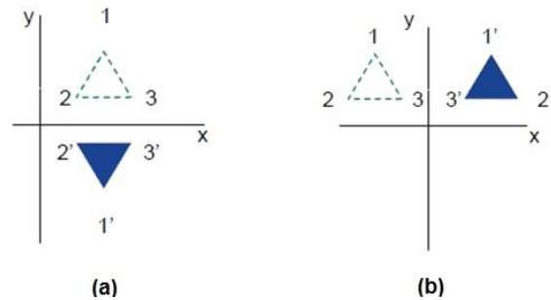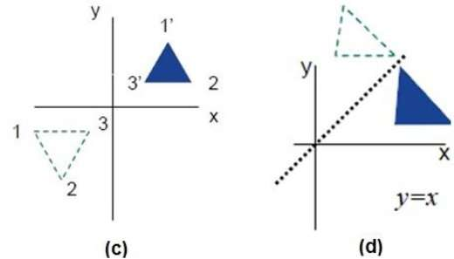

**For (a)**

Reflect over *x-*axis:

*x’= x*, *y’= −y*

or



**For (b)**

Reflect over y axis:

*x’= −x*, *y’= y*

or



**For(c)**

Reflect over origin:

*x’= −x*, *y’= − y*

or



**For (d)**

Reflect over y=x:



1. **Shearing (One coordinate is same & some change in another coordinate)**

**For x Shear**

y’=y

x’=x+shx.y



**For y Shear**

x’=x

y’=y+shy.x

